### ****TO FIND OUTLIERS****

**Interquartile Range Definition**

The interquartile range defines the difference between the third and the first quartile. Quartiles are the partitioned values that divide the whole series into 4 equal parts. So, there are 3 quartiles. First Quartile is denoted by Q1known as the lower quartile, the second Quartile is denoted by Q2 and the third Quartile is denoted by Q3 known as the upper quartile. Therefore, the interquartile range is equal to the upper quartile minus lower quartile.

**Interquartile Range Formula**

The difference between the upper and lower quartile is known as the interquartile range. The formula for the interquartile range is given below

**Interquartile range = Upper Quartile – Lower Quartile = Q­3 – Q­1**

where Q1 is the first quartile and Q3 is the third quartile of the series.

The below figure shows the occurrence of median and interquartile range for the data set.

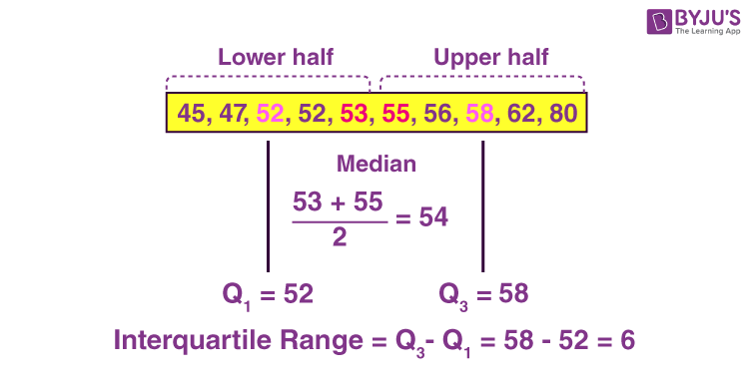

### ****Outliers****

The outliers may suggest experimental errors, variability in a measurement, or an anomaly. The age of a person may wrongly be recorded as 200 rather than 20 Years. Such an outlier should definitely be discarded from the dataset. However, not all outliers are bad. Some outliers signify that data is significantly different from others. For example, it may indicate an anomaly like bank fraud or a rare disease.

### ****Significance of outliers:****

* Outliers badly affect the mean and standard deviation of the dataset. These may statistically give erroneous results.
* Most machine learning algorithms do not work well in the presence of outliers. So it is desirable to detect and remove outliers.
* Outliers are highly useful in anomaly detection like fraud detection where the fraud transactions are very different from normal transactions.

### ****What is [Interquartile Range](https://www.geeksforgeeks.org/interquartile-range/" \t "_self) IQR?****

IQR is used to **measure variability** by dividing a data set into quartiles. The data is sorted in ascending order and split into 4 equal parts. Q1, Q2, Q3 called first, second and third quartiles are the values which separate the 4 equal parts.

* Q1 represents the 25th percentile of the data.
* Q2 represents the 50th percentile of the data.
* Q3 represents the 75th percentile of the data.

If a dataset has 2n or 2n+1 data points, then  
Q2 = median of the dataset.  
Q1 = median of n smallest data points.  
Q3 = median of n highest data points.

IQR is the range between the first and the third quartiles namely Q1 and Q3: IQR = Q3 – Q1.

The data points which fall below Q1 – 1.5 IQR

or

above Q3 + 1.5 IQR are outliers.

**Example:**

Assume the data 6, 2, 1, 5, 4, 3, 50. If these values represent the number of chapatis eaten in lunch, then 50 is clearly an outlier. Step by step way to detect outlier in this dataset using **Python**:

**Step 1: Import necessary libraries.**

import numpy as np

import seaborn as sns

**Step 2: Take the data and sort it in ascending order.**

data = [6, 2, 3, 4, 5, 1, 50]

sort\_data = np.sort(data)

sort\_data

**Output:**

array([ 1, 2, 3, 4, 5, 6, 50])

**Step 3: Calculate Q1, Q2, Q3 and IQR.**

Q1 = np.percentile(data, 25, interpolation = 'midpoint')

Q2 = np.percentile(data, 50, interpolation = 'midpoint')

Q3 = np.percentile(data, 75, interpolation = 'midpoint')

print('Q1 25 percentile of the given data is, ', Q1)

print('Q1 50 percentile of the given data is, ', Q2)

print('Q1 75 percentile of the given data is, ', Q3)

IQR = Q3 - Q1

print('Interquartile range is', IQR)

**Output:**

Q1 25 percentile of the given data is, 2.5  
Q1 50 percentile of the given data is, 4.0  
Q1 75 percentile of the given data is, 5.5  
Interquartile range is 3.0

**Step 4: Find the lower and upper limits as Q1 – 1.5 IQR and Q3 + 1.5 IQR, respectively.**

**low\_lim = Q1 - 1.5 \* IQR**

**up\_lim = Q3 + 1.5 \* IQR**

**print('low\_limit is', low\_lim)**

**print('up\_limit is', up\_lim)**

**Output:**

low\_limit is -2.0  
up\_limit is 10.0

**Step 5: Data points greater than the upper limit or less than the lower limit are outliers**

outlier =[]

for x in data:

if ((x&gt; up\_lim) or (x&lt;low\_lim)):

outlier.append(x)

print(' outlier in the dataset is', outlier)

**Output:**

outlier in the dataset is [50]

**Step 6: Plot the box plot to highlight outliers**

**sns.boxplot(data)**

